THE ENDOCRINE SYSTEM

Endocrine Glands
Functions
Same as nervous system: communication and control
Slower acting than nervous system
Effects are longer lasting
Hormones
Chemicals that influence or control the activity of a specific tissue or organ
Secreted by endocrine glands directly into blood or lymph
Exocrine glands secrete into body cavities or onto surfaces
Interact only with target cells – cells with receptors for the specific hormone
Peptide
Amino acids, peptides, proteins
Steroid
Derived from cholesterol; therefore are lipid soluble and can pass through the plasma membrane

How Hormones Function
Peptide
Bind to receptors on the plasma membrane (cell surface)
Action is mediated through 2nd messengers
The hormone itself is the first messenger
Binding to the receptors activates a second messenger inside the cell
The second messenger causes intracellular effects
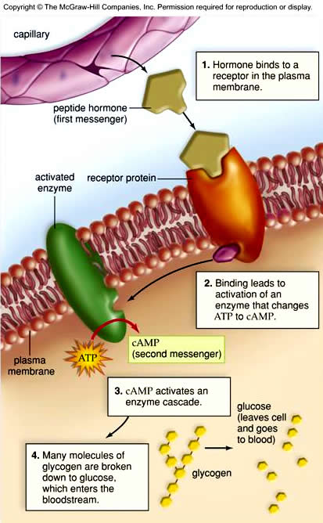
Steroids
Bind to an intracellular receptor
Hormone – receptor complex activates gene transcription, cause a protein to be manufactured
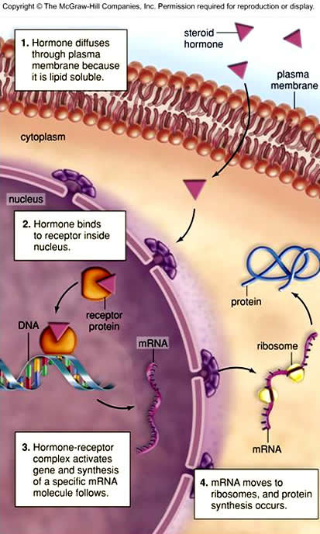

Hormone Control
Three mechanisms control release of hormones:
Humoral
Controlled by concentration of substances in the blood
Hormonal
Controlled by the action of other hormones
Stimulating or inhibiting hormones interact with other endocrine glands/tissues to control release of their hormones
Neural
Sensory input from the body stimulates sympathetic or parasympathetic activity or stimulates neuroendocrine cells to release their hormones
Feedback Loops
Negative Feedback Inhibition
Most common
Response to a stimulus reduces or removes the stimulus
Examples:
Low blood volume stimulates release of ADH, water is retained, blood volume rises, signal to release ADH is removed (low blood volume), ADH is no longer released
TRH TSH T₄/T₃ (explain with TSH/anterior pituitary)
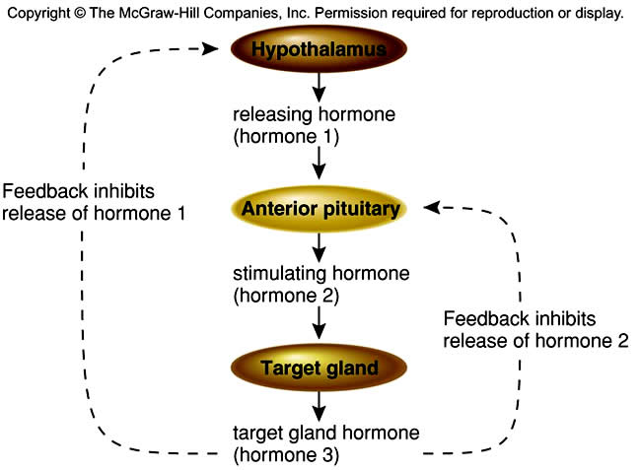
Positive Feedback Loops
Exaggerate the response until the episode is terminated
Example: Oxytocin

Hypothalamus and Pituitary Gland

Hypothalamus
Regulates internal environment, maintains homeostasis
Has centers to control heart rate, body temperature, and water balance
Also regulates the activity of the pituitary gland
Releases hormones which stimulate and inhibit release of anterior pituitary hormones
Manufactures posterior pituitary hormones
Connected to the pituitary by a stalk (infundibulum)
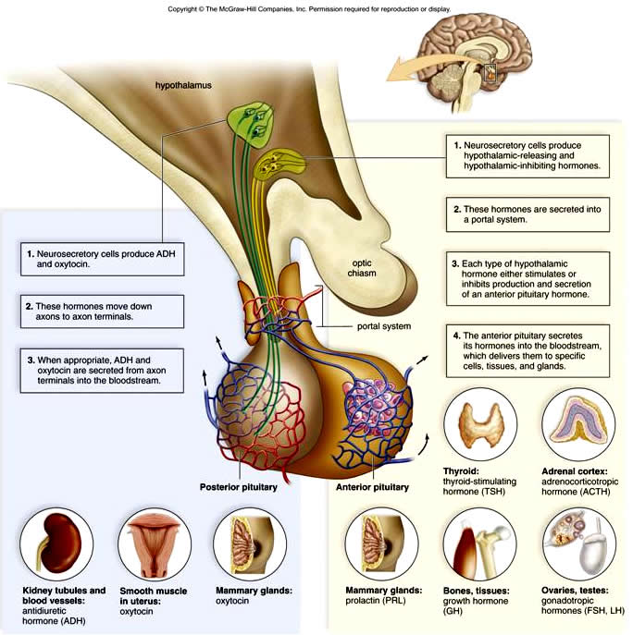

Posterior Pituitary
Stores hormones made in hypothalamus
Cell bodies (nuclei) make the hormones
Axons extend down infundibulum to posterior pituitary
Hormones are stored in axon terminals
Secretes the hormones in response to neural stimuli received at the hypothalamus
Antidiuretic hormone (ADH) or vasopressin
Promotes reabsorption of water at the kidneys, prevents dehydration
Stimulated by high blood osmolarity, sensed in the hypothalamus
Diabetes insipidus – inability to produce ADH
Oxytocin
Stimulates uterine contraction during labor
Release is stimulated by movement of baby into and down birth canal
Stimulates release of milk during nursing (contraction of myoepithelial cells)
Release is stimulated by suckling

Anterior Pituitary
Connected to hypothalamus by capillary portal system
Makes and stores hormones; secretes hormones in response to stimulus from hypothalamus
Growth hormone (GH)
Stimulates growth, affects height
Produced in greatest quantities during childhood but needed in adults to promote protein synthesis and normal cell division for repair and replacement
Dwarfism – hyposecretion during childhood, normal proportions but very small
Gigantism – hypersecretion in childhood, child grows into a giant, usually suffers from diabetes mellitus (excess GH interferes with insulin activity)
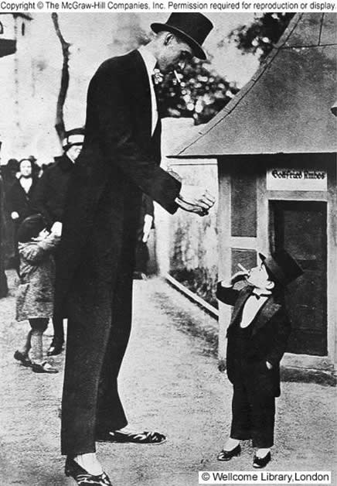
Acromegaly – hypersecretion I adulthood, epiphyseal plates have sealed so long bones no longer lengthen but jaw, browridges, nose, fingers,and toes continue to grow
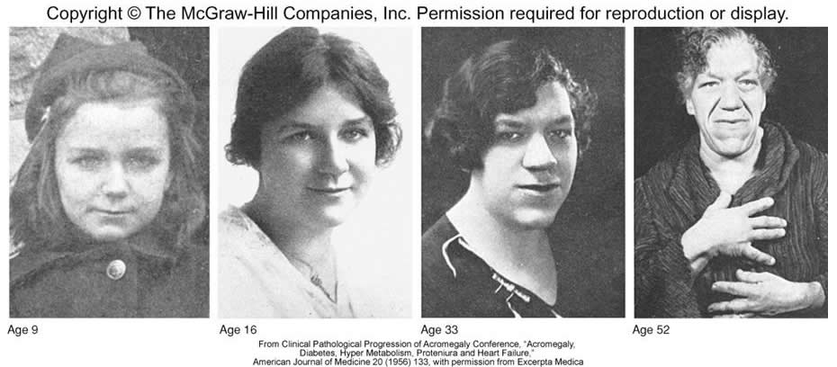
Prolactin (PRL)
Stimulates milk production by the mammary glands
Produced only after childbirth
Thyroid stimulating hormone (TSH)
Stimulates thyroid to produce thyroxine
Adrenocorticotropic hormone (ACTH)
Stimulates adrenal cortex to produce cortical hormones
Gonadotropic hormones
Stimulate the gonads (ovaries and testes)
Follicle stimulating hormone (FSH)
Lutinizing hormone (LH)
Proopiomelanocortin
A prohormone that must be cleaved to be active
When cleaved gives rise to at least 3 active proteins
ACTH
Melanocyte stimulating hormone (MSH)
Stimulates melanin production in lower vertebrates
Probably more important as a neurotransmitter in humans
UV irradiation is the more important stimulator of melanin production in humans
b-endorphin

Thyroid and Parathyroid Glands

Thyroid
Attached to trachea just inferior to the larynx
Thyroid cartilage is the Adam’s apple
Composed of follicles
Spherical structures surrounded by thyroid cells
Contain thyroglobulin – protein precursor of thyroid hormone
Requires iodine to finish making thyroid hormone
Iodine is actively transported to thyroid gland
Concentration may be 25x higher than elsewhere in the body
Produces thyroxin (thyroid hormone)
Occurs and is secreted in two forms, T₄ and T₃
Denotes number of iodine atoms attached
T₃ is more active, T₄ is eventually converted to T₃ at the target cell surface
Hypothyroidism
Low levels of thyroxin in the blood
Causes
Low or absent TSH - Low or absent TRH – hypothalamic problem or TRH released but no TSH released – pituitary problem
Inability of TSH to stimulate thyroid follicle cells – Hasimoto’s thyroiditis: autoimmune attack on the thyoid destroys the gland
Lack of iodine – thyroglobulin (colloid) builds up in follicles but no thyroxine can be made
Effects
Simple goiter – swelling of the thyroid due to lack of iodine, used to be common in the midwest
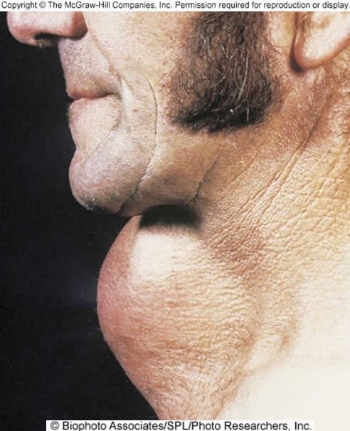
Myxedema – in adults, lethargy, weight gain slow bradycardia, low body temperature (all due to decreased BMR), loss of hair, puffiness of skin
Cretinism – in children or infants, due to failure of thyroid to develop properly; leads to short, stocky stature and mental retardation
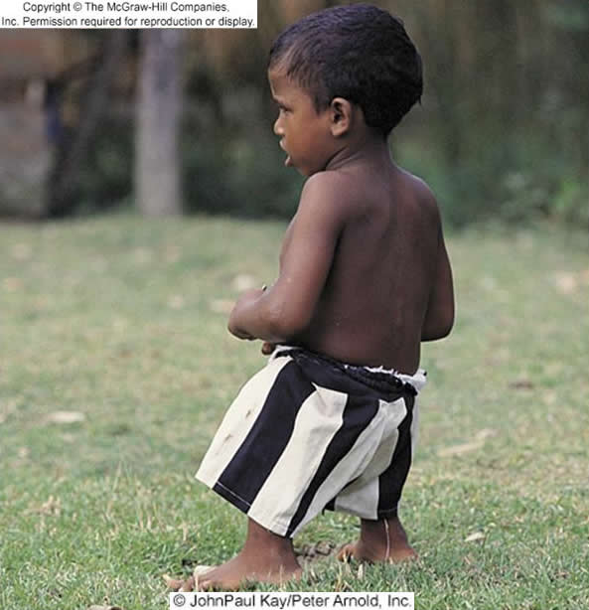
Treatments
Simple goiter – iodized salt
Myxedema and cretinism – synthetic thyroxine; however infants suffering from thyroid dysfunction must receive treatment within first 2 months to avoid mental retardation
Hyperthyroidism – Grave’s disease
Enlargement and overactivity of thyroid
Increased BMR; increased heart rate, exopthalmic goiter due to edema in eye socket and swelling of extrinsic eye muscles
Autoimmune stimulation of TSH receptors
Surgery or radioablation followed by synthetic thyroxine therapy
Calcitonin
Produced by parafollicular cells located between follicles
Regulates blood calcium levels by stimulating uptake of calcium by bone
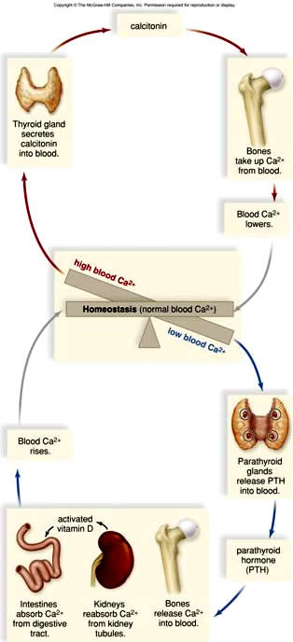

Parathyroids
Four small glands located on the posterio-lateral aspect of the thyroid
Produce parathyroid hormone (PTH)
Regulates blood calcium levels by stimulating the release of calcium from bone when blood calcium levels are low

Adrenal Glands
Located on top of kidneys

Adrenal medulla
1. Stimulated by the sympathetic nervous system
2. Produces epinephrine (adrenalin) and norepinephrine (noradrenalin)
a. Responsible for flight or flight syndrome
b. Stimulate increases in blood glucose levels, metabolic rate, breathing rate, heart rate, cardiac contractile force, vasodilation of blood vessels feeding skeletal muscle, bronchiodilation, and vasoconstriction of blood vessels to the digestive tract

Adrenal cortex
Stimulated by ACTH from pituitary in response to stress
ACTH release stimulated by the hypothalamus remember
Secretes glucocorticoids, mineralocorticoids, and low levels of gonadocorticoids (sex hormones)
Glucocorticoids (cortisol is major) promotes
Hydrolysis of proteins to release amino acids which are then converted to glucose
Mobilization of fatty acids for energy
Glucose sparing reactions
Anti-inflammatory also
Mineralocorticoids
Aldosterone is major
Regulates sodium re-absorption by the kidney (which is balanced by potassium excretion)
Water follows sodium, so aldosterone is water-conserving
Secreted in response to the renal enzyme renin, which is secretedby the kidneys in response to low blood pressure or high blood osmolarity
Renin converts angiotensinogen to ATI, which is then converted to ATII, which stimulates aldosterone release, vasoconstriction, and ADH release
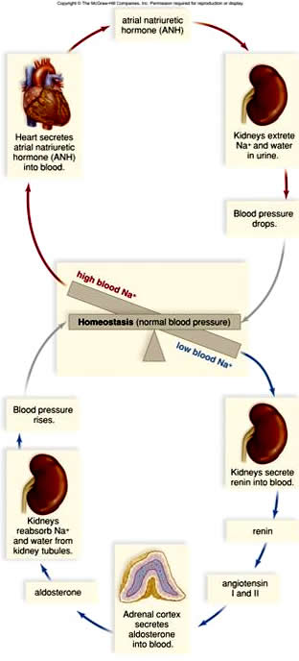
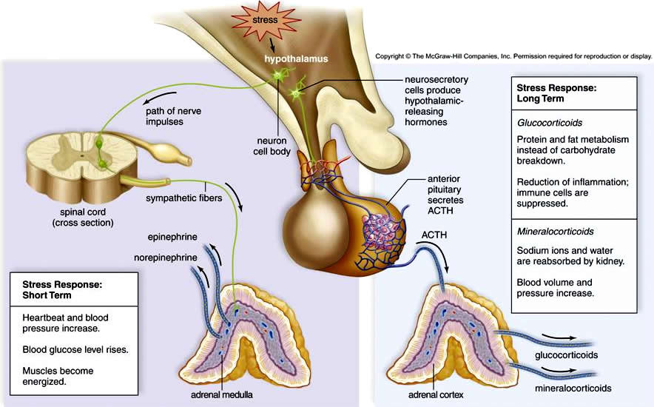
Disorders of the Adrenal Cortex
Addison’s Disease - low levels of gluco- and mineralocorticoids
Susceptible to severe blood glucose drops due to no cortisol
Low sodium levels, low blood volume, susceptible to severe dehydration
Bronzing of the skin – feedback mechanisms fouled up, MSH produced in high quantities.
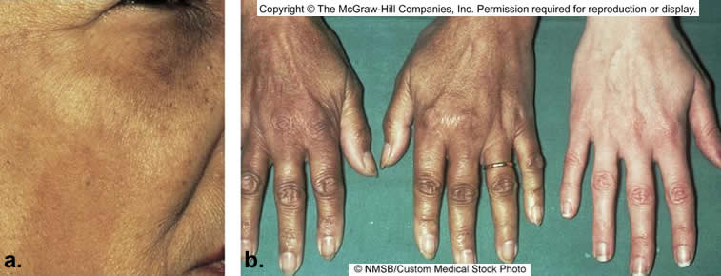

Cushing’s Syndrome – high levels of adrenal cortex hormones
Tendency to develop diabetes mellitus, decrease in muscular protein, increase in subcutaneous fat, hypernatriemia, increased blood volume, hypertension, moon face (edema) and possible virilization in women
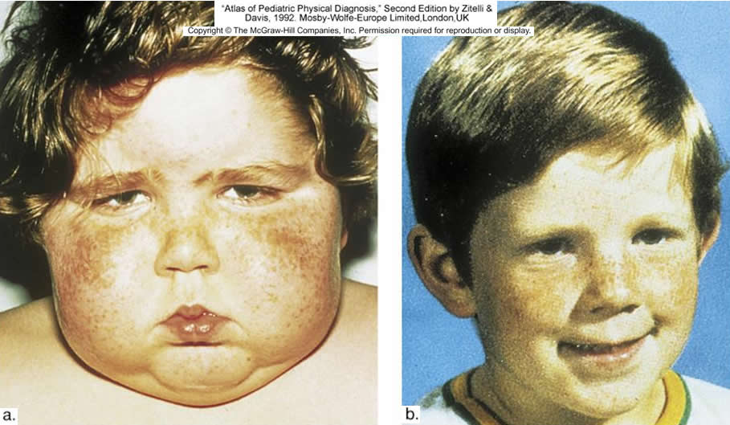

Pancreas
Islets of Langerhans
Endocrine portion of gland
Exocrine function for most of gland (digestive enzymes)
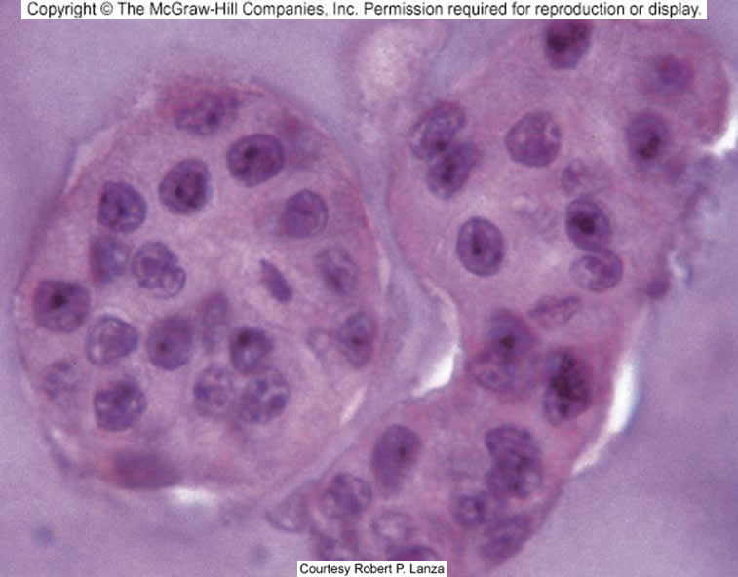
Insulin
Promotes uptake and usage of glucose by cells
Promotes glycogen synthesis
Promotes buildup of fats and proteins
Inhibits use of fats and proteins as an energy source
Secretion stimulated by high blood glucose levels
Lowers blood glucose levels to normal limits
Glucagon
Opposite effects of insulin
Secreted in response to low blood glucose levels
Raises blood glucose levels by stimulating breakdown of glycogen
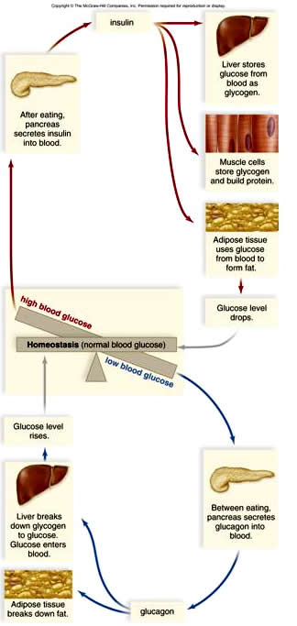

Diabetes Mellitus
Most common hormonal disease
Due to either lack of insulin or inability of insulin to stimulate cells to take up glucose
Hallmarks:
Polyuria – glucose levels exceed ability of kidney to reabsorb, spill into urine, act as an osmotic stimulatory of water movement into urine
Polydipsia – thirst to replace lost fluid leads to high fluid intake
Polyphagia – hunger because cells can’t use available glucose
Ketosis, metabolic acidosis
Due to utilization of fats for energy since glucose can’t be used
Type I
Insulin-dependent (used to be called juvenile onset)
Pancreas doesn’t produce insulin
Genetic predisposition, due to autoimmune destruction of islet cells
Type II
Non-insulin dependent (formerly adult onset)
Also has genetic risk factors but etiology is different
Due to inability of insulin to stimulate cells even though it is present
Obesity is a risk factor
Can usually be controlled with diet and exercise
Complications of diabetes
Blindness, kidney disease, circulatory disorders (heart disease and strokes), risk of diabetic coma
Gestational - due to placental hormonal influences on insulin activity, usually disappears after childbirth

Other Endocrine Glands

Testes and Ovaries
Testosterone
Male sex hormone
Essential for normal development and functioning of the male sex organs
Growth of penis and testes at puberty
Maturation of sperm
Stimulates development of secondary sex characteristics
Facial, axillary, and pubic hair
Enlargement of larynx and vocal cords – voice change
Stimulates skeletal muscle development and closure of epiphyseal plates
Contributes to greater strength in males as compared to females
Stimulates secretion of sebaceous and sweat glands
Acne
Body odor
Contributes to pattern baldness (DHT)
Stimulates sex drive
Can contribute to aggressivness
Therapeutic use
Prevent muscular atrophy in long term illness
Promote healing in burn and surgery patients (GH may be better)
Used to treat rare forms of anemia and breast cancer
Abuse
Doses at 10 to 100x therapeutic promote great gains in muscle mass when paired with resistance exercise
Negative feedback inhibition of GnRH release causes testes to atrophy, sperm counts and sex drive to drop
High androgen levels cause acne, baldness, and agression (‘roid rage)
Promote liver and kidney damage, including cancer, dysregulation of lipoprotein metabolism (leads to heart disease), and inability to regulate fluid balance (steroid bloat, which leads to hypertension, which also contributes to heart disease and risk of stroke
When discontinued hypothalamus doesn’t resume release of GnRH, prostate enlarges, gynecomastia may occur
Women may develop male sexual characteristics; stop ovulataing or menstruating, grow facial and body hair, lose hair from the scalp, and experience breast reduction and clitoral enlargement
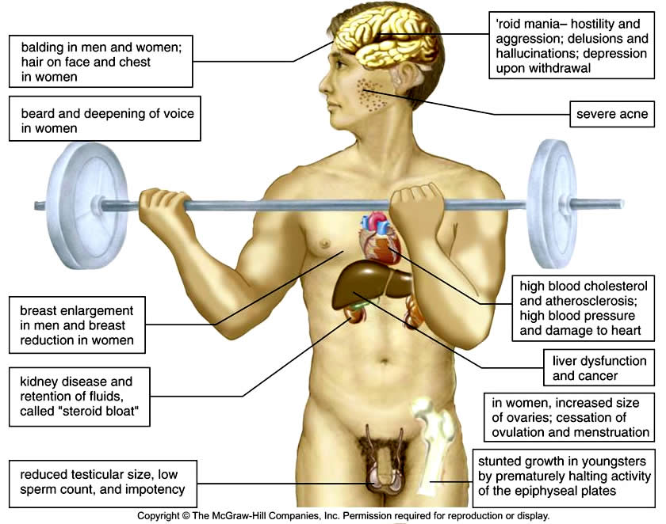
Estrogen and Progesterone
Estrogen secreted at puberty stimulates growth of the uterus and vagina, required for egg maturation
Stimulates female secondary sex characteristics
Body hair and fat distribution
Breast enlargement (promotes growth and maintains size)
Promotes closure of epiphyseal plates, enlargement of pelvic girdle
Stimulates higher HDL levels (protective against heart disease)
Feminizes the brain
Estrogen and progesterone together regulate menstrual cycle and breast development (maturation to milk-producing glands), maintain the uterus during pregnancy

Thymus Gland
Located in upper thoracic cavity (neck along trachea to mediastinum)
Largest in children, atrophies with age until nearly gone by early 20’s
Site of T cell maturation
Produces thymosins
Hormones that stimulate T cell maturation
May be good therapeutic agents for treatment of immunodeficiencies (including AIDS)

Pineal Gland
Cone shaped gland in the roof of the third ventricle
Smaller than the pituitary, atrophies with age
Innervated through the optic chiasma (light sensitive)
Produces melatonin (don’t confuse with melanin)
Secreted in response to declining light levels
Regulates sleep-wake cycles (promotes sleep)
Jet lag (take it on the west to east trip, lets your body go to sleep on local eastern time when it is still awake on the earlier western time)
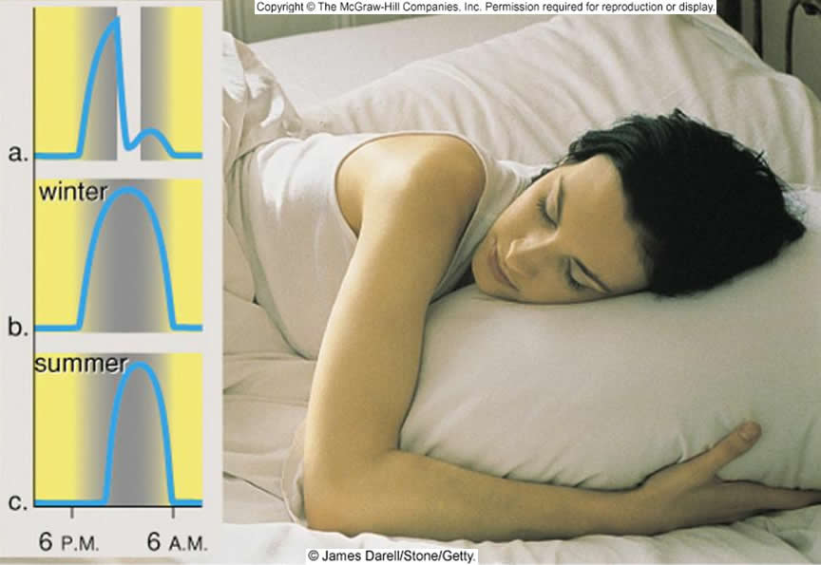
High amounts contribute to SAD
Treat with bright light therapy to cause breakdown
Inhibits secretion of FSH and LH
Lower animals
Sex organs enlarge in the summer
Mating occurs in the fall
Young are born in the spring
Humans – children with tumors that destroy the pineal gland go through early puberty

Endocrine Tissues
Non-glandular tissues which secrete hormones
Heart
Atrial natriuretic hormone (ANH) secreted by atria in response to high blood volume
Also secreted by cells in the aorta, ventricles, lungs, and pituitary
Promotes renal excretion of sodium and water to lower blood volume and thus pressure
Stomach and Small Intestine
Secrete peptide hormones that regulate digestive activity
Pancreas already mentioned

Paracrine Factors
Growth factors
Platelet-derived growth factor
Secreted from platelets and other cell types
Promotes wound healing
Promotes increases in some cells in nervous system
Epidermal growth factor
Stimulates growth of epidermis
Nerve growth factor
Stimulates growth of neurons
Tumor angiogenesis factor
Promotes vascularization of tumors (secreted by tumors)
Prostaglandins
Derived from arachadonic acid
Many different kinds, many different effects
Blood clotting/inhibition of blood clotting
Generally promote inflammation; inhibited by aspirin, acetaminophen, or ibuprofen
Inhibit synthesis

Effects of Aging
Most endocrine glands shrink with age but maintain function
Most common problems with thyroid and pancreas (Graves disease and diabetes)

